**WEEK 2 ASSIGNMENT SOFTWARE ENGINEERING**

1. Downloading windows 11

Through the link <https://www.microsoft.com/software-download/windows11> one is able to access the windows installer assistant. Through the assistant it then scans if the PC is compartible for the download thus starts the download.

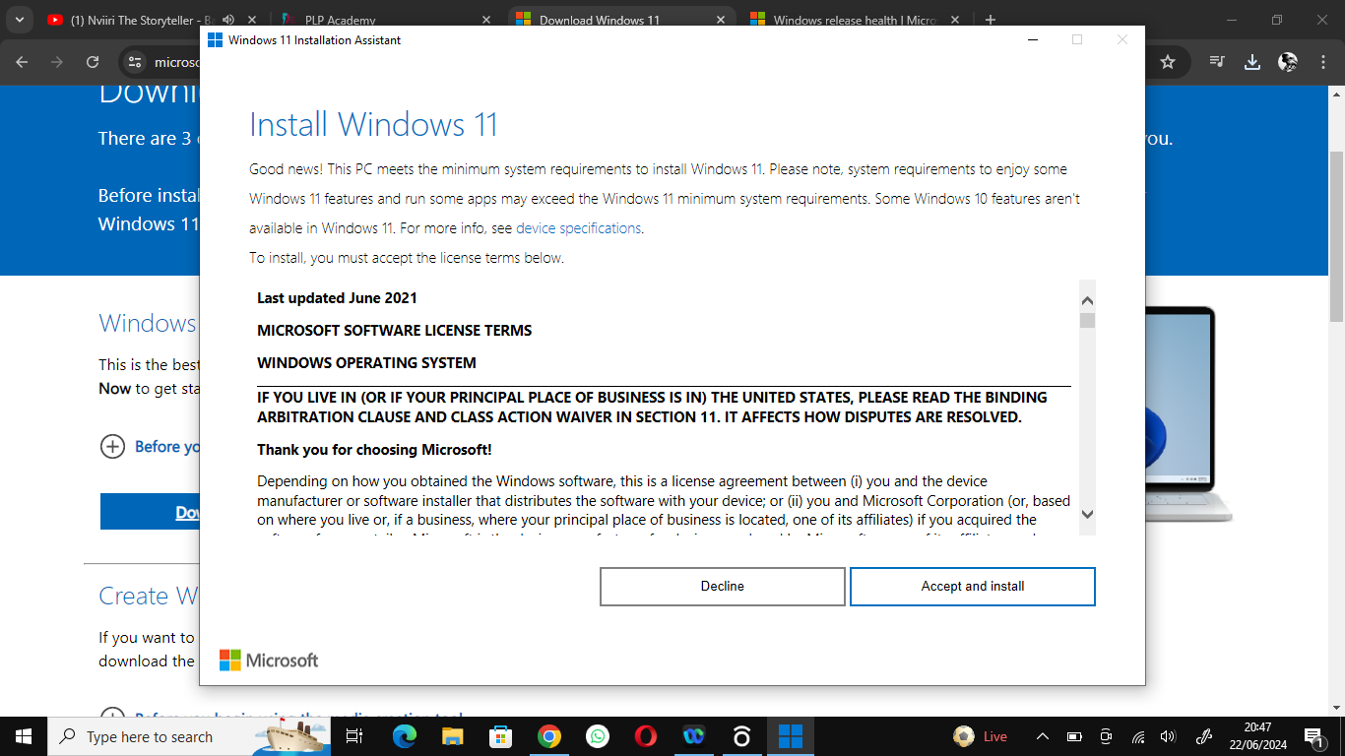

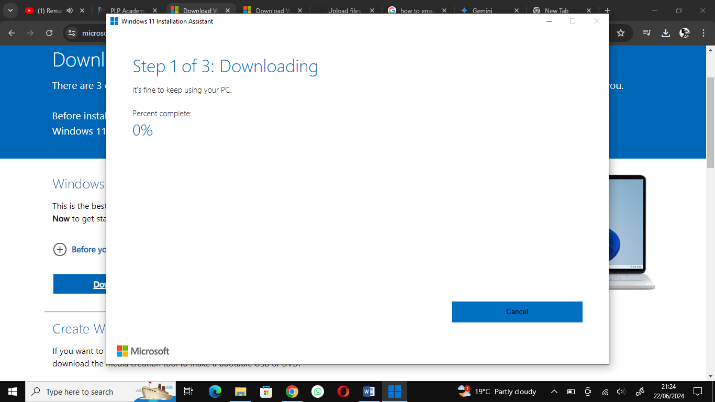

1. Downloading VS code

This involves getting t o your favourite browser searching for VS code downloader and starting the download. Afterwards download the programming languages required and start coding.

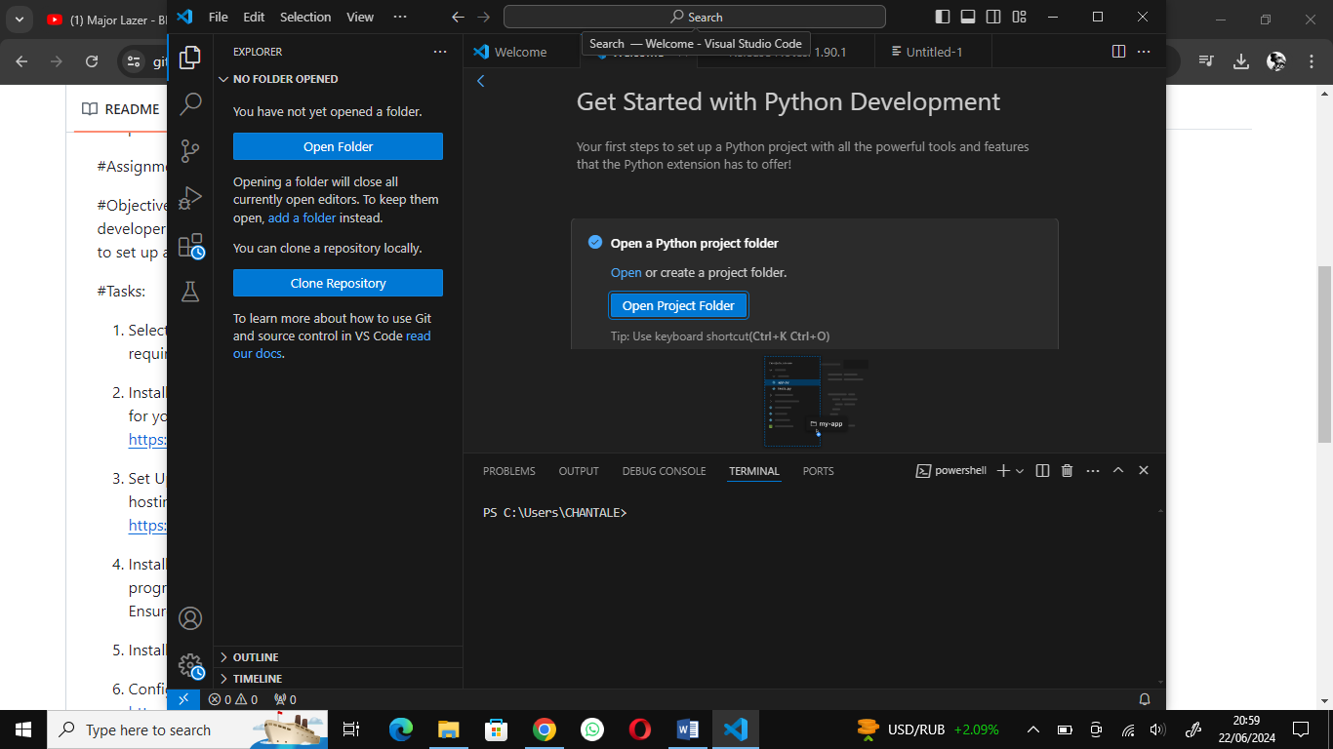

1. Installing GIT and configure it; create a github repository

After installing the git from the browser configure it using your name or email. Open a github account and create a repository. Configure your github to your git bash .

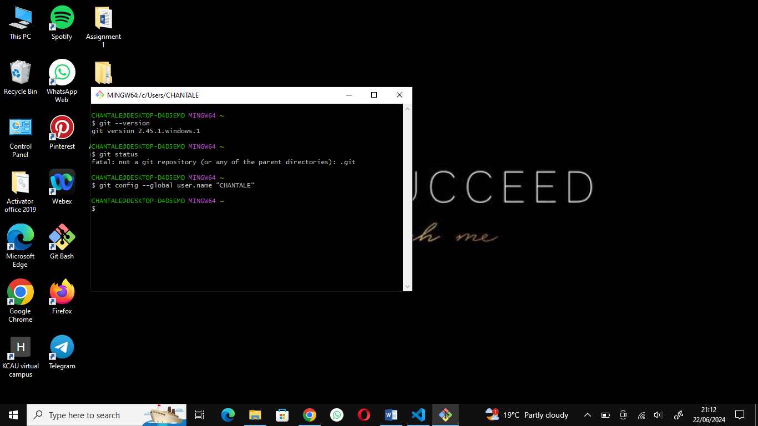

4.INSTALLING PYTHON

Well I had trouble with downloading python and after clicking download it only brought me to another tab with the following instructions.

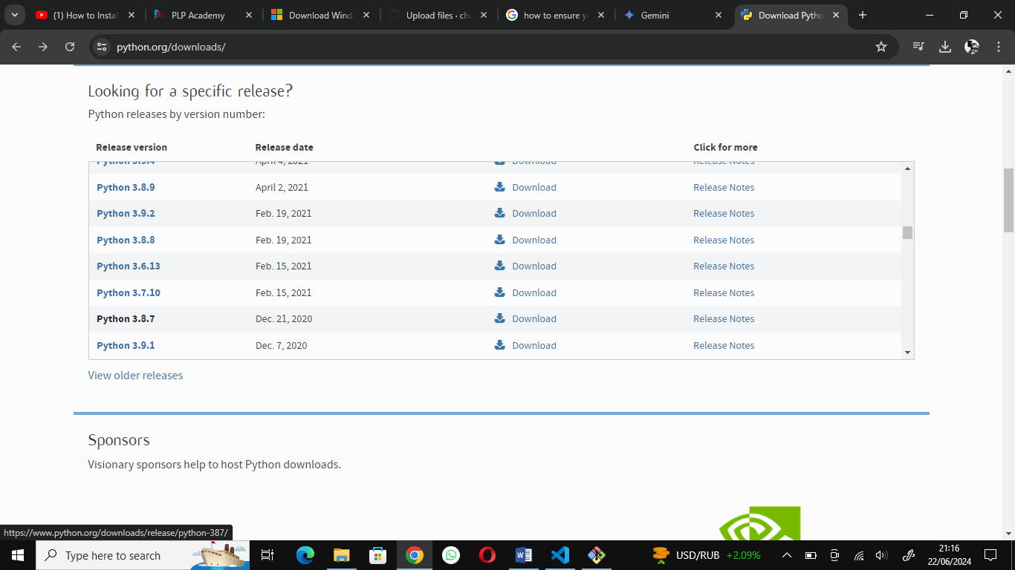

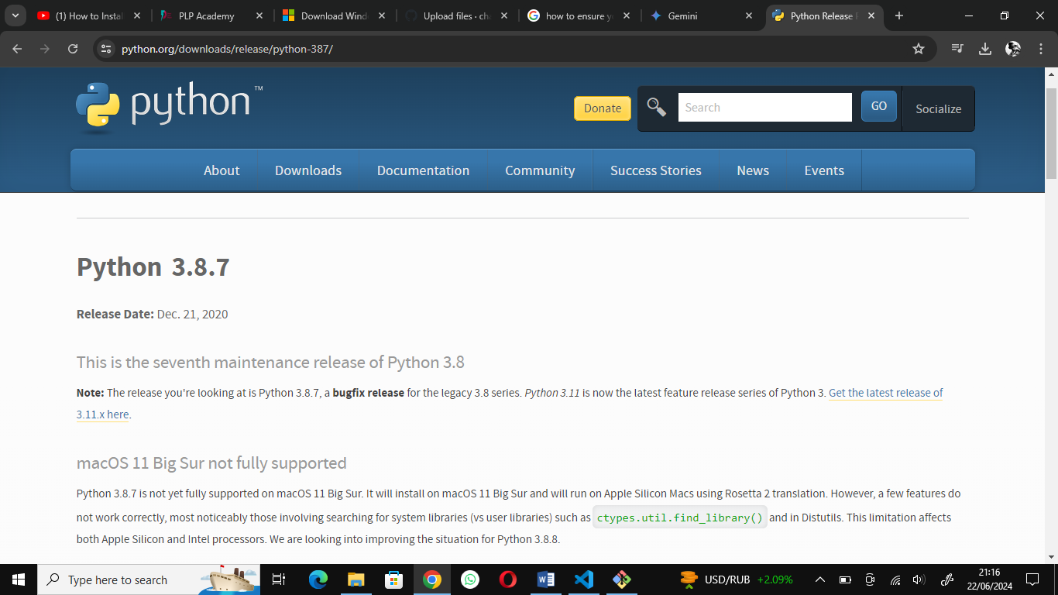

5.INSTALLING AND CONFIGURING MYSQL

